TRANSMISSION LINES AND RADIATING SYSTEMS

**RECTANGULAR WAVEGUIDE :**

Question:

* Design of WR8 rectangular waveguide

A = 2.032mm

B = 1.016mm

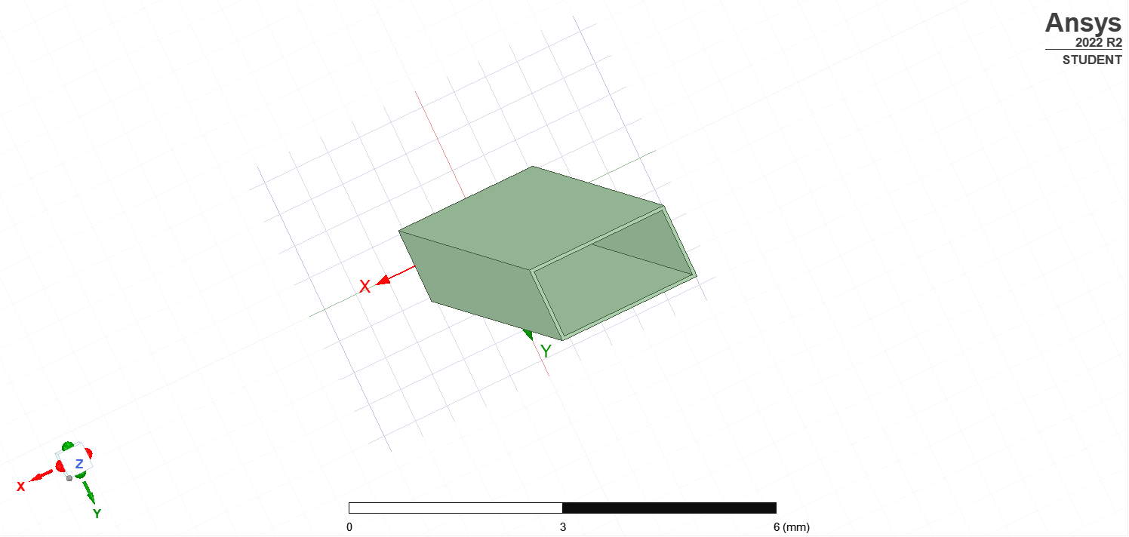

**ANALYSIS:**

1. Sweep from 70-295GHz
2. Analysis must include first three modes (TE10, TE20, TE01)
3. Generate a graph for β, λ, η vs. frequency for each mode

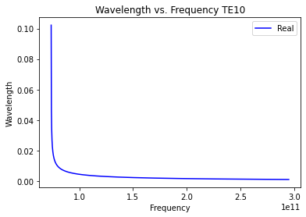

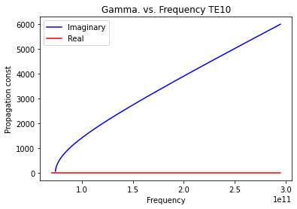

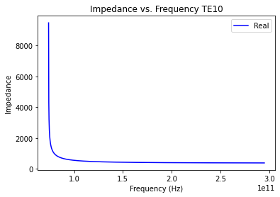

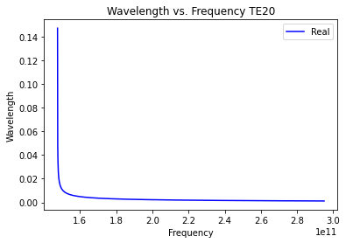

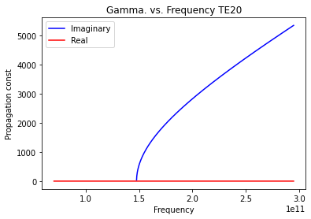

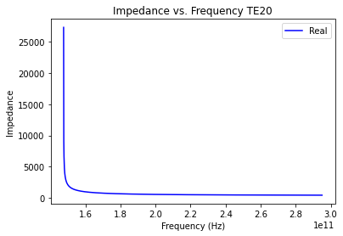

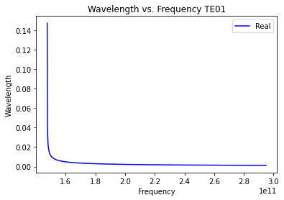

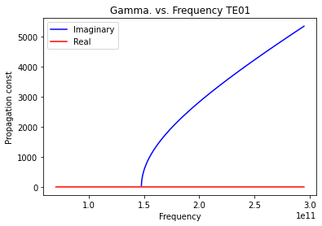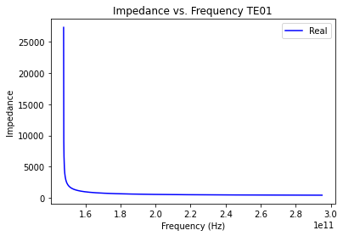

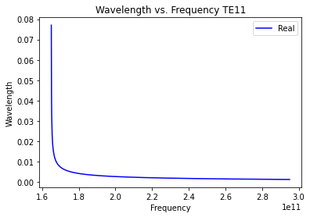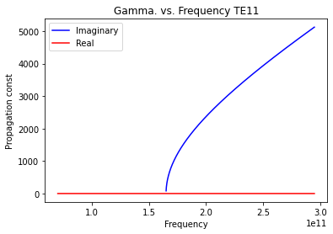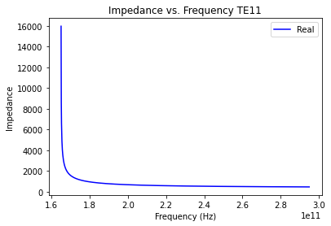

Code :

import numpy as np

import matplotlib.pyplot as plt

a = 0.002032

b = 0.001016

m = [1, 2, 0, 1]

n = [0, 0, 1, 1]

mur = 1

er = 1

mu = mur * 4 * np.pi * 1e-7

e0 = er * 8.854e-12

f = np.linspace(70*(10**9), 295*(10**9), 2000)

for j in range(4):

fc = (1/(2 *np.pi*np.sqrt(mu*e0)))*(np.sqrt(((m[j]*np.pi)/a)**2+((n[j]*np.pi)/b)**2))

w = 2*np.pi*f

beta = np.zeros(2000)

wl = np.zeros(2000)

impedance = np.zeros(2000)

for i in range(2000):

beta[i] = w[i]*np.sqrt(mu*e0)*np.sqrt(1-(fc/f[i])**2)

wl[i] = (2*np.pi)/beta[i]

impedance[i] = (np.sqrt(mu/e0))/(np.sqrt(1-(fc/f[i])**2))

print(f"Cutoff frequency : {fc/10**9} Ghz")

plt.plot(f, np.real(wl), 'b')

plt.xlabel('Frequency')

plt.ylabel('Wavelength')

plt.legend(['Real'])

plt.title("Wavelength vs. Frequency TE" + str(m[j]) + str(n[j]))

plt.show()

plt.plot(f, np.real(beta), 'b', f, np.imag(beta), 'r')

plt.xlabel('Frequency')

plt.ylabel('Propagation const')

plt.legend(['Imaginary', 'Real'])

plt.title("Gamma. vs. Frequency TE" + str(m[j]) + str(n[j]))

plt.show()

plt.plot(f, np.real(impedance), 'b')

plt.xlabel('Frequency (Hz)')

plt.ylabel('Impedance')

plt.legend(['Real'])

plt.title("Impedance vs. Frequency TE" + str(m[j]) + str(n[j]))

plt.show()